https://keras.io/api/applications/
https://distill.pub/2018/building-blocks/
https://playground.tensorflow.org/#activation=relu&batchSize=6&dataset=circle&regDataset=reg-plane&learningRate=0.003&regularizationRate=0&noise=0&networkShape=2,1&seed=0.91364&showTestData=false&discretize=false&percTrainData=60&x=true&y=true&xTimesY=false&xSquared=false&ySquared=false&cosX=false&sinX=false&cosY=false&sinY=false&collectStats=false&problem=classification&initZero=false&hideText=false

https://deeplizard.com/resource/pavq7noze2

https://deeplizard.com/resource/pavq7noze3

What is a Single-Layer Perceptron?
A single-layer perceptron (SLP) is the simplest neural network possible.
It has one layer of trainable weights and no hidden layers.
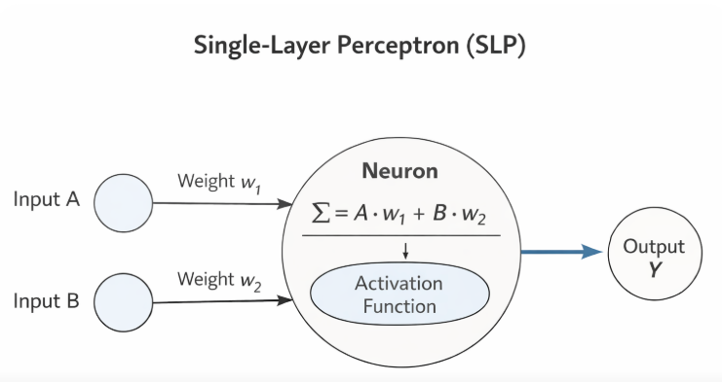
Structure:
Inputs → Perceptron → Output
How it works (mechanically)
Given inputs $x_{1},x_{2},...,x_{n}$:
- Multiply each input by a weight
- Add them up
- Add a bias
- Pass through an activation function (usually a step function)
Equation:
$$y=f\left(\sum_{i=1}^{n}{w_{i}}x_{i} + b\right)$$
Where:
- $w_{i}$= weights
- $b$= bias
- $f$= activation function

Typical activation function
Historically, the perceptron uses a binary step function:
$$f(z)=\left\{\begin{matrix}1 & z≥0 \\ 0 & z<0\end{matrix}\right.$$
So the output is only 0 or 1.

What problems can a single-layer perceptron solve?
✔ Linearly separable problems
That means:
You can separate the classes using one straight line (2D) or one hyperplane (higher-D)
Examples it CAN solve:
- AND gate
- OR gate
- Simple spam / not-spam (if separable)
AND gate:
A | B | AND
0 | 0 | 0
0 | 1 | 0
1 | 0 | 0
1 | 1 | 1
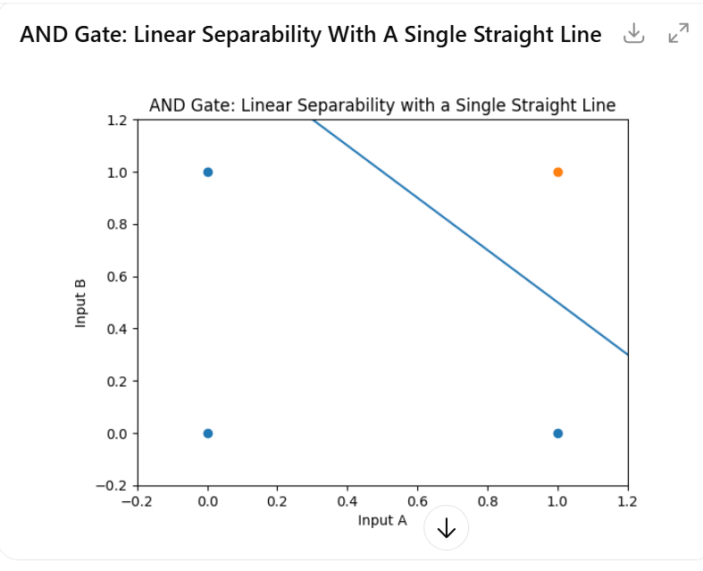
A single straight line separates output 1 from 0 ✅

1️⃣ How an artificial neuron works (simpler than you think)
An artificial neuron is just a tiny math machine inspired by a biological neuron.
Think of it like this:
“Should I fire or not, based on the inputs I get?”
What it does:
- Takes inputs (numbers)
- Multiplies each input by a weight (importance)
- Adds a bias (adjustment)
- Passes the result through an activation function
Formula:
$$\text{output}=\text{activation}\left(∑(input×weight)+bias\right)$$
Example:
Inputs:
- $x_{1}=1$, $x_{2}=0$
Weights:
- $w_{1}=0.8$, $w_{2}=-0.4$
Bias:
- $b=-0.2$
$$z=(1⋅0.8)+(0⋅-0.4)-0.2=0.6$$
Now the neuron asks:
“Is 0.6 enough to activate?”
That decision is made by the activation function 👇

2️⃣ Why we need activation functions
Without activation functions, neural networks are just linear models (basically fancy regression).
What activation functions do:
- Introduce non-linearity
- Allow networks to learn complex patterns
- Decide how strongly a neuron fires
Common ones:
- Step function → yes/no decision
- Sigmoid → smooth probability (0–1)
- ReLU → keeps positives, kills negatives
- Tanh → outputs between −1 and 1
💡 Key idea
No activation function = no deep learning magic.

3️⃣ How layers connect to form networks
A neural network is just neurons stacked in layers:
Structure:
Input Layer → Hidden Layer(s) → Output Layer
What happens:
- Each layer transforms the data
- Outputs of one layer become inputs to the next
- Deeper layers learn more abstract patterns
Example:
- Input layer: raw data (e.g., 0s and 1s)
- Hidden layer: learns combinations/features
- Output layer: final decision
📌 Important:
Each neuron in a layer is usually connected to all neurons in the next layer (fully connected).

4️⃣ Why the XOR problem needs hidden layers
Now for the famous part 😄
XOR truth table:
A | B | A XOR B
0 | 0 | 0
0 | 1 | 1
1 | 0 | 1
1 | 1 | 0
The problem:
- XOR is not linearly separable
- You cannot draw a single straight line that separates 1s from 0s
📉 That means:
A single neuron (or single-layer perceptron) cannot learn XOR

5️⃣ XOR gate using a hidden layer (this is the key!)
Network architecture for XOR:
A B XOR
0 0 0
0 1 1
1 0 1
1 1 0
- Input layer: A, B
- Hidden layer: 2 neurons
- Output layer: 1 neuron
Intuition:
- Hidden neuron 1 learns A OR B
- Hidden neuron 2 learns A AND B
- Output neuron combines them to produce XOR
Logic:
$$\text{XOR}=(A\text{ OR }B)-(A\text{ AND }B)$$
🔥 This combination requires a hidden layer.

6️⃣ Visual intuition (very important)
Imagine points on a graph:
(0,1) ● ● (1,1)
|
|
(0,0) ● ● (1,0)
- XOR wants diagonal points = 1
- Straight line ❌ can’t separate them
- Two lines (hidden neurons) ✅ can
That’s why depth matters.

🚀 Big takeaway
- Artificial neuron = weighted sum + activation
- Activation functions = enable non-linearity
- Layers = progressively smarter transformations
- XOR proves:
You need hidden layers to learn complex logic
If you want, I can:
- Show XOR with actual weights
- Explain XOR using ReLU vs sigmoid
- Connect this directly to deep learning intuition
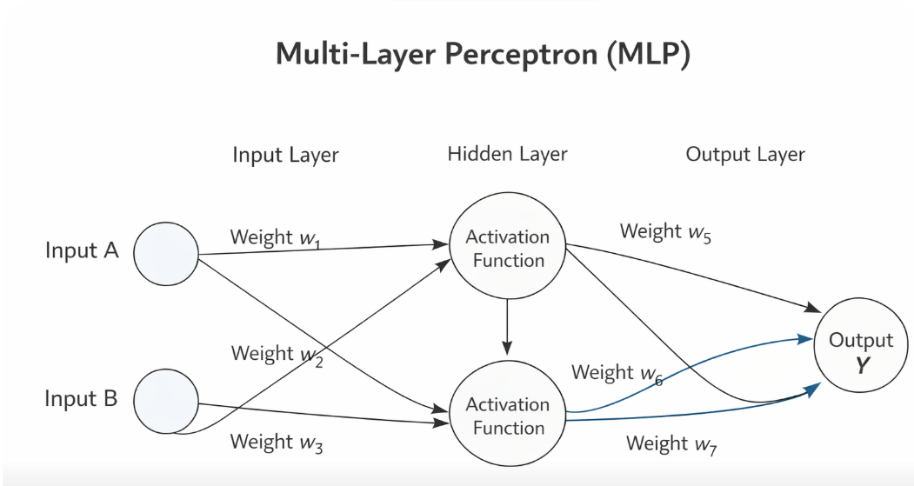

Solution :

XOR Gate Using a Hidden Layer
This document explains how a neural network with one hidden layer can solve the XOR problem using simple arithmetic, just like a pen-and-paper calculation.

1. XOR Truth Table
A B XOR
0 0 0
0 1 1
1 0 1
1 1 0
XOR is not linearly separable, so we need a hidden layer.

2. Network Architecture
Input Layer: x₁ = A, x₂ = B
Hidden Layer: 2 neurons (H₁ and H₂)
Output Layer: 1 neuron
Activation Function: Step function

3. Activation Function
f(z) = 1 if z ≥ 0
f(z) = 0 if z < 0

4. Weights and Biases
Hidden Neuron H₁ (OR gate):
z₁ = 1·x₁ + 1·x₂ − 0.5
Hidden Neuron H₂ (AND gate):
z₂ = 1·x₁ + 1·x₂ − 1.5
Output Neuron:
z₃ = 1·H₁ − 2·H₂ − 0.5

5. Example Calculation: x₁ = 0, x₂ = 0
H₁: z₁ = (1·0 + 1·0) − 0.5 = −0.5 → H₁ = 0
H₂: z₂ = (1·0 + 1·0) − 1.5 = −1.5 → H₂ = 0
Output:
z₃ = (1·0) + (−2·0) − 0.5 = −0.5 → XOR Output = 0

6. Final Insight
The hidden layer transforms the input space so that XOR becomes linearly separable. This is why a hidden layer is essential for solving the XOR problem.

XOR Decision Boundary Diagram and Explanation
This document explains how a neural network with one hidden layer creates decision boundaries to solve the XOR problem.

1. Input Space
The XOR dataset consists of four points in a 2D input space (x1, x2). The classes cannot be separated using a single straight line.

2. Decision Boundary Diagram
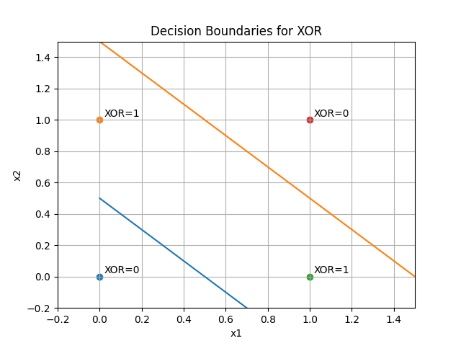

3. Hidden Layer Interpretation
Hidden Neuron H1 learns an OR-like boundary: x1 + x2 = 0.5.
Hidden Neuron H2 learns an AND-like boundary: x1 + x2 = 1.5.
These two boundaries divide the input space into regions.

4. Output Layer Decision
After transformation by the hidden layer, the output neuron can linearly separate the XOR classes. This makes XOR solvable.

5. Key Insight
The hidden layer transforms a non-linearly separable problem into a linearly separable one by creating multiple decision boundaries.

- McCulloch–Pitts Neuron (1943) — First Neural Model
“Can neurons be used to do calculations like a computer?”

“
What problem were they trying to solve?
They wanted to understand:
“How can thinking and reasoning happen in the brain?”
Since computers were new, they asked:
“Can the brain work like a logical machine?”
“
- Perceptron (1958) — First Trainable Neural Network
“Can a machine learn from data like the brain?”

- ADALINE & MADALINE (1960) — Learning with Gradients
“ADALINE and MADALINE improved the Perceptron by using gradient-based learning instead of simple mistake correction.”

- Hopfield Network (1982) — Neural Associative Memory
“Can a neural network store memories like the human brain?”
Hubel & Wiesel’s Experiment (1960s)

- In the 1960s, David Hubel and Torsten Wiesel conducted famous experiments on cats
- They studied how a cat’s brain processes visual information
- Their work focused on the visual cortex
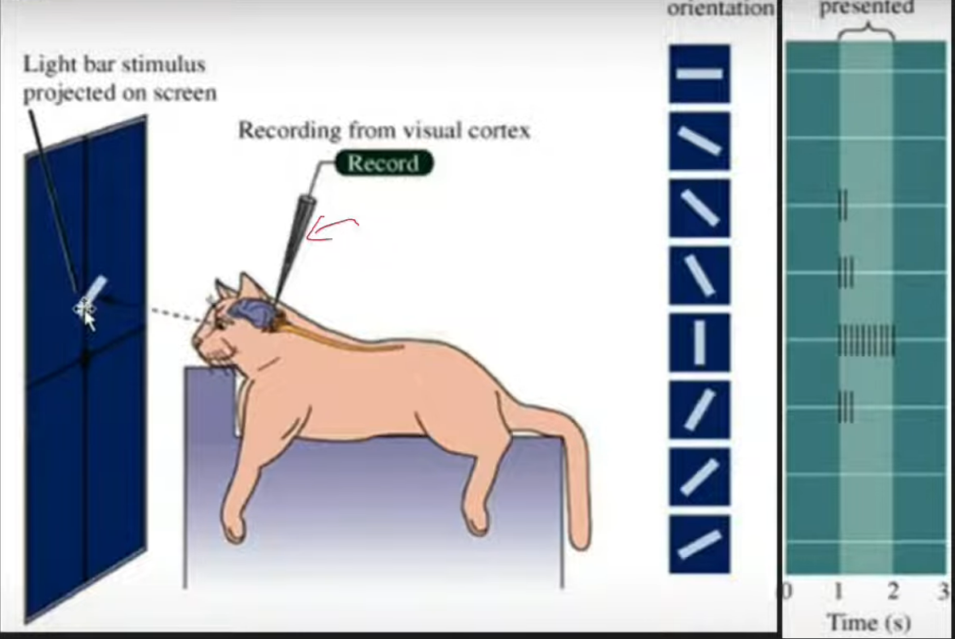

What They Discovered
They found that:
- Neurons in the visual cortex do not see the whole image
- Each neuron responds only to a small region of the image
- Some neurons respond to:
  - Edges
  - Lines
  - Orientation (vertical, horizontal, slanted)
Types of Cells They Identified
1. Simple Cells
Detect basic features, especially:
- Edges
- Orientation (direction of lines)
Have a small receptive field
- Respond to a small area of the image
Respond best to a preferred stimulus
2. Complex Cells
Detect the same features, but:
- Work over a larger area
- Are less sensitive to exact position
Have a bigger receptive field
- Help with movement and pattern recognition
Why This Is Important for CNN
Their experiments inspired CNN concepts:
- Local receptive fields
- Hierarchical feature learning
- Edge → shape → object progression

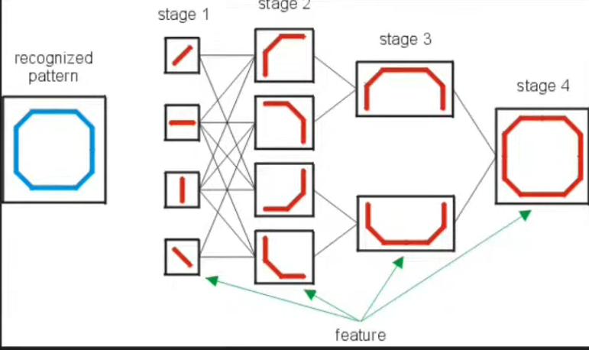

👉 CNNs work the same way:
- Early layers → edges
- Middle layers → shapes
- Deep layers → objects

What is a CNN (Convolutional Neural Network)?
Convolutional Neural Networks (CNNs), also called ConvNets, are a special type of neural network designed to process data that has a grid-like structure, such as:
- 1D data → Time-series signals
- 2D data → Images (pixels arranged in rows and columns)

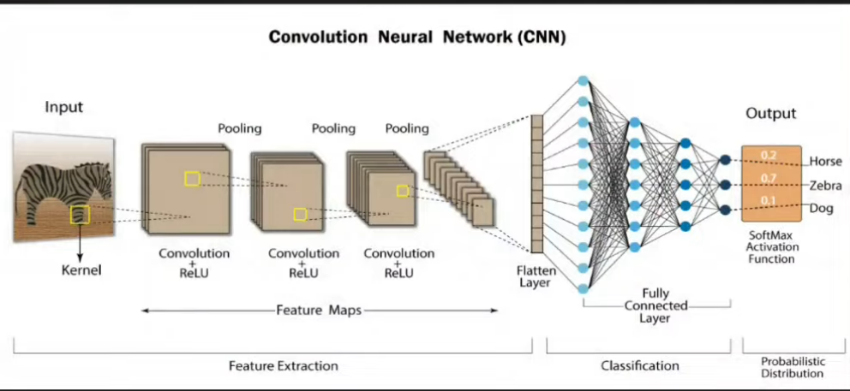
Yann LeCun and Convolutional Neural Networks (CNN)
Yann LeCun introduced convolutional neural networks trained using backpropagation, leading to the LeNet architecture for handwritten digit recognition.

Simple Flow :
Input → Convolution → Pooling → Convolution → Pooling → Fully Connected → Output

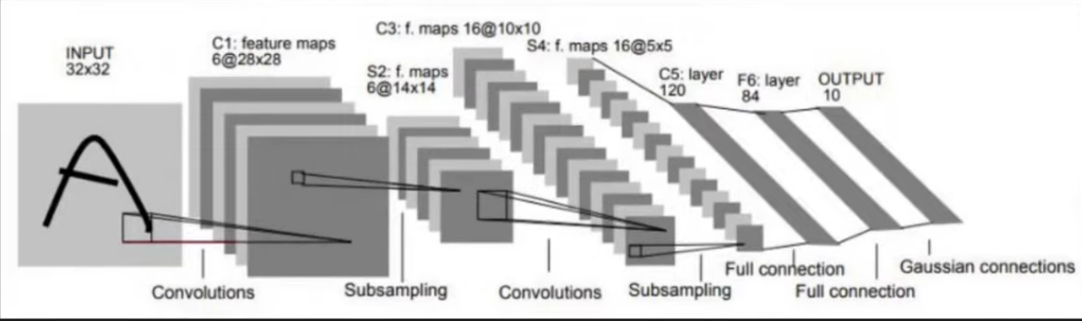

2012 – AlexNet – ImageNet Breakthrough
What Happened in 2012?
- In 2012, AlexNet was introduced by Alex Krizhevsky, Ilya Sutskever, and Geoffrey Hinton
- AlexNet won the ImageNet Large Scale Visual Recognition Challenge (ILSVRC)

Why AlexNet Was Important
- Achieved a huge improvement in image classification accuracy
- Reduced error rate dramatically compared to previous methods
- Marked the deep learning revolution in computer vision

Simple Timeline (Easy to Remember)
- 1980 → Neocognitron (Fukushima)
- 1998 → LeNet (Yann LeCun)
- 2012 → AlexNet + ImageNet = CNN breakthrough

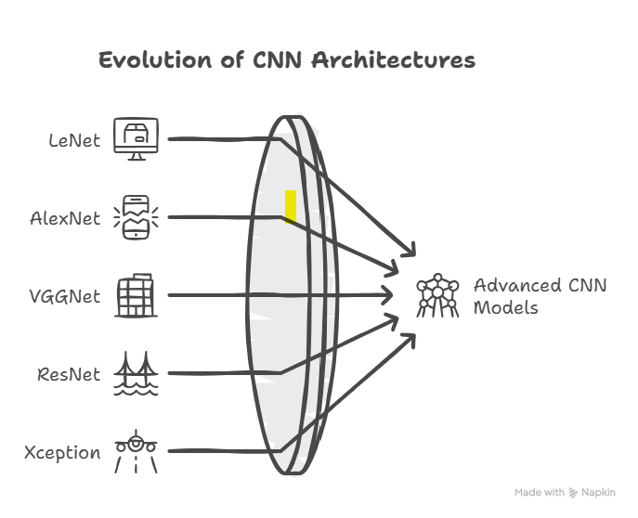
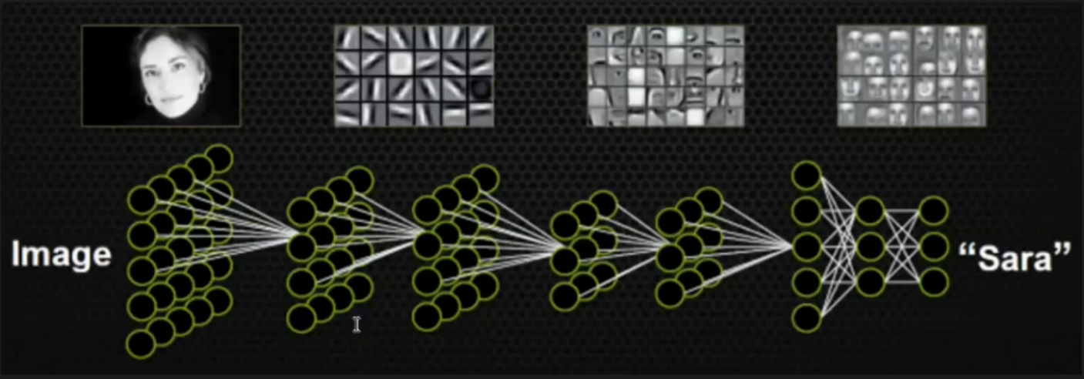

🧠 Big Picture Evolution Summary
Era | Focus
1940s–60s | Neurons & learning rules
1980s | Backprop & memory
1990s | Vision & CNNs
2000s | Deep learning revival
2010s | GPUs, CNN dominance
2020s | Transformers & foundation models

Edge Detection (Using Convolution Operation)
What is Edge Detection?
Edge detection is a technique used to:
- Find boundaries in an image
- Detect places where pixel values change sharply
- Highlight shapes and object outlines

